Level: Gr 7
Category: Numeracy
Title of Lesson: Integers
Goals/Objectives:
Big Idea: • computational fluency can be extended to integers
Curricular Content:
• operations with integers (addition, subtraction, multiplication, division, and order of operations)
Curricular Competencies: visualizing and representing number; communicating number

Materials Needed:
- Deck of Cards

Task Instructions: (Step by Step)
Activity 1: Visualizing and Decomposing Numbers
You add two integers and get a result of -2.
What integers might they be?
What different ways can you represent the operation?
Try and think of at least five different ways you might get this answer.
Consider using symbols, pictures, words, grids/arrays, equations, etc.

Find 2 integers that have a sum of -12 and a difference of 2.
How do you know that your numbers work?
How will you show your thinking?

Choose an amount: $999.85 or $999 999
What are some different ways can you make this amount with bills and/or coins?
What are three items that cost about this much?
Activity 2: Fluency Practice

Integer Rummy:
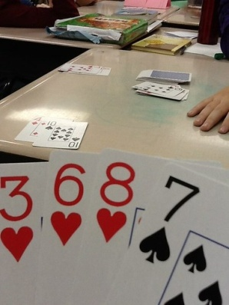
The red cards are negative and the black are positive. Each player starts with 6 cards, drawing one at the beginning of their turn and discarding one at the end. The goal is to play pairs that equal 6 or -6. The person playing 3 pairs first wins the round. The other players add the absolute value (disregarding colour/sign)of their pairs to get a score for that round. The goal is to have the lowest score at the end of the 10 rounds.

Activity 3: Open Question

How can you tell if the sum of two integers will be positive, negative or zero?
Use a diagram or number line to explain your understanding.

Adaptations/Adjustments: (consider different environments)
-Look at the activities in the Grade 6 Week 1 Lessons
Extensions (Optional):

References:
SD38-Janice Novakowski
https://www.weareteachers.com/math-card-games/

