Mirzakhani Mathematics Contest
Up to Grade 6
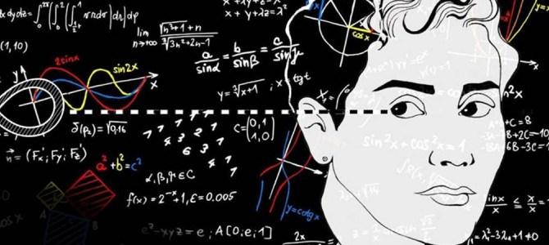
May 2019

Image: Adapted from Maryam Mirzakhani by Assad Binakhahi, CC BY 2.0

“It’s not only the question, but the way you try to solve it.”
-Maryam Mirzakhani, Fields Medal Winner
1977-2017

Contest Rules
- Calculators may be used
- Select the best answer
- Write answers on Answer Form
- Diagrams are not always to scale

- Time limit: One Hour

- Two big rings—one grey and one white—are linked to each other. Maryam, in front of the rings, sees the rings as in this picture:
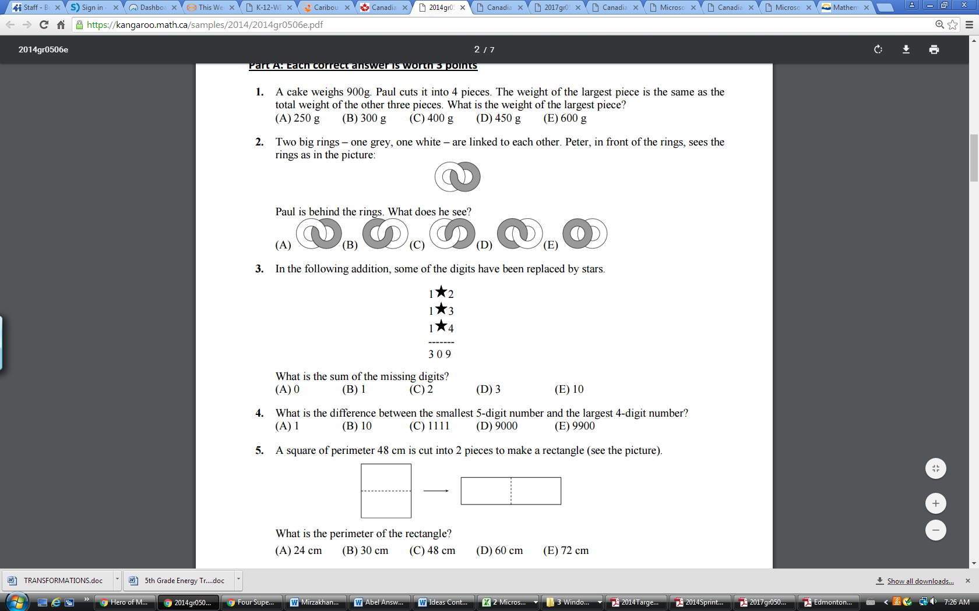
Jo is behind the rings. What does she see?

2. How would you write 10 000 as a decimal of one million?
A) 1 B) 0.1 C) 0.01 D) 0.001 E) 100

3. What is the solution to the equation below:
10 × 4 - 2 × (16 ÷ 4) ÷ 2 × 4 + 9 = ?

A) 33 B) 35 C) 47 D) 65 E) 99

4. Samira bought 7 t-shirts, one for each of her cousins, for $9.95 each. The cashier charged her an additional $13.07 in sales tax. She left the store with a measly $7.28. How much money did Samira start with?
A) $70.00 B) $80.00 C) $90.00 D) $100.00 E) $105.00

5. Wei is thinking of two numbers. Their greatest common factor is 6. Their least common multiple is 36. One of the numbers is 12. What is the other number?
A) 3 B) 6 C) 9 D) 16 E) 18

6. Which of the following numbers IS NOT equivalent?
A) 14% B) $\frac{7}{5}$ C) 1.40 D) $\frac{28}{20}$ E) $1\frac{2}{5}$
7. Mary, Nate and Amrit work in a daycare for the summer. Each day from Monday to Friday, exactly two of them come to work. Mary works 3 days per week and Nate works 4 days per week. How many days per week does Amrit work?
A) 2 B) 3 C) 4 D) 5 E) 6

8. Five squirrels, A, B, C, D and E are sitting on a line (see picture below). There are 6 nuts on the line as well (marked by X). At the same time, and all with the same speed, the squirrels start running to the nearest nut to them. As soon as a squirrel picks up a nut, it starts running to the next closest nut. Which squirrel will get 2 nuts?
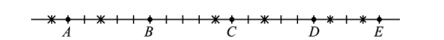
A) A B) B C) C D) D E) E

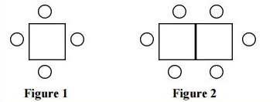
9. Luigi started a small restaurant. His friend Mario gave him several square tables and chairs. If he uses all the tables as single tables (Figure 1) with 4 chairs each, he would need 6 more chairs. If he uses all the tables as double tables with 6 chairs each (Figure 2), he would have 4 chairs left over. How many tables did Luigi get from Mario?
A) 8 B) 10 C) 12 D) 15 E) 18

10. The price of a computer after discount was $1200. If the discount was 20%, what was the original price?
A) 1000 B) 1440 C) 1480 D) 1500 E) 1550
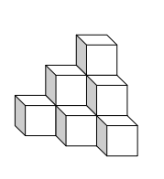
11. The 10 blocks in the pile at right are glued together in this shape. After they dry, they are painted. How many faces are painted?
A) 18 B) 24 C) 30 D) 36 E) 40

12. A bag contains 8 red balls, 2 green balls, and 2 yellow balls. If you randomly choose one of these balls, what is the probability that the ball chosen is yellow?
A) 1/6 B) 2/6 C) 2/8 D) 2/10 E) 1/2
13. Which represents a rotation of the figure?
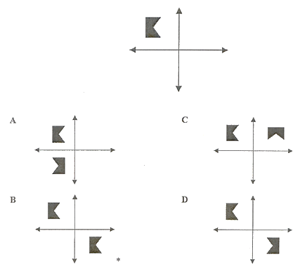
A) A only B) A & C C) C only D) C & D E) A, C & D

14. There are about 7.06 billion people in the world, and there are about 35 million people in Canada. What percent of the world population is in Canada?
A) 0.005 % B) 0.05 % C) 0.5% D) 5.0 % E) 5.5 %

15. What is the value of X in the equation:
372 = 3X + 12
A) 112 B) 124 C) 120 D) 1116 E) 1128

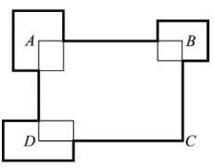
16. The perimeter of rectangle ABCD is 30 cm. 3 other rectangles are placed so that their centers are at the points A, B and D (see figure). The sum of the perimeters of the small rectangles is 20 cm. What is the total length of the dark line around the outside of the rectangles?
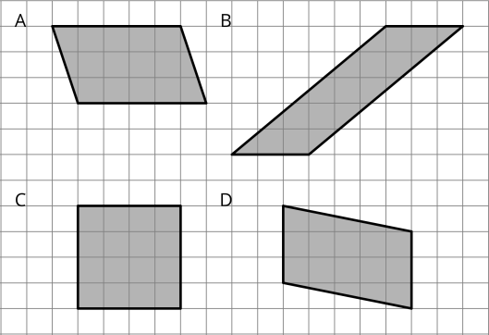
A) 40 cm B) 45 cm C) 50 cm D) 47 cm E) impossible to determine

17. Examine the parallelograms in the diagram at right. Which ones have the same area?

A) A & B B) B & C C) A, B & C D) A, B & D E) C & D

18. A positive number has 3 digits. The product of the digits is 135. What is the sum of the digits?
A) 14 B) 15 C) 16 D) 17 E) 18

19. What is the greatest number when divided by 7 has a remainder that is equal to the quotient?
A) 7 B) 38 C) 48 D) 56 E) 67

20. The diagram below is a scale representation of the distance between Mara’s and Bunica’s houses. One half, one quarter and one eighth of the distance are marked on the diagram. What is the real distance between the houses?
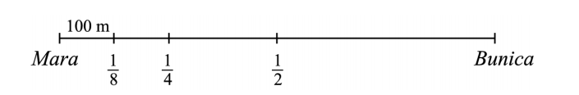

A) 300 m B) 400 m C) 500 m D) 600 m E) 800 m
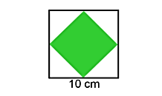
21. Jan draws a square of area 100 cm², then joins the midpoint of the sides to make a smaller square (see diagram at right). What is the area of the smaller square?
A) 10 cm² B) 20 cm² C) 25 cm² D) 40 cm² E) 50 cm²

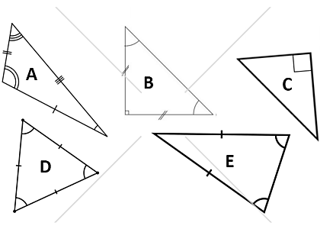
22. Which of the triangles below has angles of 60 º, 60 º and 60º?

A) A B) B C) C D) D E) E

23. There are 12 black marbles and 20 white marbles in a bag. If you pick one marble out of the bag randomly, what is the probability it is black?
A) 2/4 B) 3/8 C) 1/3 D) 1/2 E)1/4

24. Which letter represents the decimal 0.014?

B
C
A
D
E

25. Ala likes even numbers. Beto likes numbers divisible by 3. Corry likes numbers divisible by 5. They went one at a time to a basket containing eight balls with numbers they liked on them. They took all the remaining balls with the numbers they liked. Ala collected balls with 32 and 52 on them. Beto collected balls with 24, 33 and 45 on them. Corry collected balls with 20, 25 and 35 on them.
In what order did they approach the basket?
A) Ala, Beto, Corry B) Beto, Corry, Ala C) Corry, Ala, Beto D) Ala, Corry, Beto E) Corry, Beto, Ala

