Thermal Energy Kit—for Grade 3 Science
Grade 3 Big Ideas:
All matter is made of particles. (Why is matter known as the material of the universe? How are matter and energy related?)
Thermal energy can be produced and transferred. (What can be a source of thermal energy? How is thermal energy transferred between objects?)
A good place to start could be to identify the sources of thermal energy: chemical reactions (e.g., hand warmers), friction between moving objects, the sun, etc. We want students to understand that heat is the movement of atoms – atoms move more when matter is warmed up and move less when matter is cooled down.
MATERIALS IN KIT:
Thermometers—9 digital thermometers
Incredible Ice Melting Blocks (1 set)
Wooden Spoons—2
Metal spoons—2
Plastic spoons—2
White and black dishes
White and black plastic lids
White and black t-shirts
8 Large containers with lids
8 small containers with lids
8 bags wool
8 bags cat tail fluff
8 bags wood chips
Radiometer (**DELICATE, FOR TEACHER DEMONSTRATION ONLY)
Glass convection ring and clamp (**DELICATE, FOR TEACHER DEMONSTRATION ONLY)

REFILLABLES IN KIT:
Handwarmers (20 per time)

YOU PROVIDE:
Food colouring
Hot Water
Aluminum Foil
Black paper/crepe paper
Lamps
Ice Cubes
A candle
ACTIVITIES to BUILD UNDERSTANDING
Why use a thermometer?

Fill the cup labelled HOT with very warm water (but not burning the skin) from the tap, and the cup labelled COLD with ice water. Fill the third cup labelled ? with room temperature water. Have a student place a finger in the HOT cup, and another place a finger in the COLD cup. After 15-20 sec, have them move their fingers to the same ? cup. Ask them if it is warm or cool.

Use the thermometers to measure the actual temperatures of the water.

Have students use the thermometer (see instructions included in appendix). Things to NOTE: make sure that the thermometers are set to CELSIUS; because they are meat thermometers, the ends are pointy so they need to be cautious, both to avoid hurting themselves and to avoid poking holes in the bottom of the containers later on.
Squeeze the thermometer with their hands. Read the temperature when it stops changing quickly. Then ask students to rub their hands quickly together for 1-2 minutes. Take the temperature again. Did it go up?
Heat Vs. Temperature
Have them measure the temperature of a large container of hot water vs. a small container of hot water. Repeat the measurement each minute for 10 minutes. Why does the small container cool down more quickly? Use this to discuss HEAT versus TEMPERATURE.
Heat can be transferred by Conduction, Convection and Radiation
Conduction Experiments:
Use hand warmers included in kits (chemical reaction – oxidization of iron): students could measure the temperature change of the material in various types of containers—plastic, styrofoam, metal.
You could also do conduction experiments by giving students a variety of objects (metal, wood, plastic…) to place on or in the pouch and have them determine what is a good conductor. You could also use a variety of cups and students could determine which are better insulators. There are quite a few possibilities for structured, guided and open inquiry.
Another experiment for conduction is to use a container of hot water and place the 3 different spoons (included in kit) in the hot water (metal, wood and plastic). Which spoon would be best for stirring soup as you cook? Which spoon might cool down your hot chocolate faster?
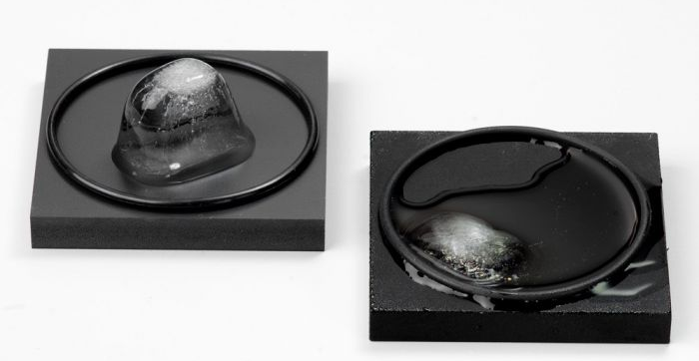
Use ice in the same way as the hand warmer but with cooling. Have students test melting times with different types of cups.
The incredible ice melting blocks included with the kit are a great opportunity for students to do a PREDICT/OBSERVE/EXPLAIN activity. Have them touch the blocks before you place ice on them and PREDICT what will happen to the ice. They can explain why. Then place an ice cube on each block, and observe for 2-5 minutes. Write down their observation, then explain why it was the different or the same as their prediction. Find PEOE forms at the appendix or on the Science Blog.
Convection Experiments:
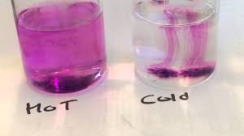
Use the clear plastic cups provided in the kit and a drop of food colouring (you provide) to observe the difference in convection in hot, warm and cool water. This can also be done on a larger scale in a fish tank if you have one.
For the more adventurous, here is a great demonstration on convection: https://www.stevespanglerscience.com/lab/videos/colorful-convection-currents-sick-science-075/
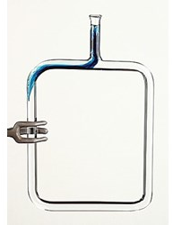
The kit includes a convection ring. Fill the ring with water. Hold it using the clamp around the rubber stopper. Tell students you are going to hold one corner over a heat source (candle is ok, nothing hotter), and drop one drop of food colouring in the opening. Ask them to predict what will happen. (The colour will flow down towards the opposite corner from the candle, as the heat causes the water to rise up, creating a circular current).
You might also use real life experiments such as drying paper, mittens etc, in different circumstances (e.g. sun vs. shade, over a heat source, such as a vent or a hair dryer).
Radiation
The radiometer is a device that spins when in contact with heat. Hold it near an incandescent (old fashioned or halogen) light, compared to a fluorescent light. When does it spin faster?
Put some different colours of cloths or use the two t-shirts in the kit in the sun for an hour or more. Feel the temperature of the material. Why do we wear white clothes in summer? Students might do an inquiry around the temperatures inside the shirts.
Use the two identical dishes in the kit, one hot and one cold. Run hot water from a tap for a minute or two, until it reaches its maximum temperature. Fill the dishes with hot water and move them to a dark, cool room. Place a thermometer in each one and wait 20 minutes. Read the thermometer in each cup and compare the temperatures and colors. The darkest sup should read the coolest because, just as black is better at absorbing heat energy, it also radiates heat energy more efficiently than light colors.
Consider tracking the sun through the year: https://www.teachersource.com/product/sun-tracker-kit/astronomy-space
ACTIVITIES for CHALLENGE and INQUIRY
Test various materials using either warm water or ice water to see how temperature changes when insulated. Using the big containers and small containers, choose one of the sets of insulators (natural materials used by First Nations people: wood chips, wool, cat-tail fluff) and design the best insulator. Put hot water (or use ice water and look for an increase in temperature) in the small inner cup. Record the temperature change over 10 minutes (see hand-out in appendix). On the science blog, you can find a powerpoint that introduces this activity.
The hand warmers can also be used to pose challenges to the students: You could activate some hand warmers before class and have student conduct tests to determine when it was activated. Or you could tell students the goal is to build an insulating container that will keep the temperature above room temperature for the longest.
Consider making useful items that use solar energy—for example, a pizza box solar oven: https://ualr.edu/gifted/files/2016/03/lesson-7-modification-solar-oven-lesson-plan.pdf
Have students make solar balloons (this could meet design criteria as well): https://www.instructables.com/id/Solar-Balloon-1/

APPENDICES FOR KIT
POE Chart for Introducing Heat
PEOE Chart--general
Introduction to Heat (copies of PPT slides)
Radiation (copies of PPT slides)
Container Challenge Instructions (copies of PPT slides)
Thermometer Instructions
Melting Plate Instructions
Designing and Recording Chart for Insulation Activity (chart can be used for any other temperature measuring activity).
4 pager on Heat Energy
All Thermal Energy links available on the Burnaby Science Blog at
http://blogs.sd41.bc.ca/science/new-curriculum-support/dlrc/thermal-energy/

GRADE 3 ENERGY SUMMARY
Grade 3 Learning Standards (From BCEd Curriculum)
- What is Thermal Energy?
- The energy that comes from the movement of particles within matter
- Most easily understood as heat
- sources of thermal energy
- thermal energy can be produced by chemical reactions (e.g., hand warmers), friction between moving objects, the sun, etc.
- transfer of thermal energy
- conduction (touching — e.g., hold an ice cube)
- convection (current — why do we hang mittens over a heat source?)
- radiation (through space by a wave — e.g., heat from the sun)
WHAT DO Grade 3’s need to know about Thermal Energy?
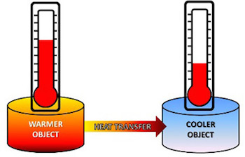
All matter is made up of molecules and atoms. These atoms are always in different types of motion, including vibrating. The motion of atoms and molecules creates heat or thermal energy. All matter has this thermal energy. The more motion the atoms or molecules have the more heat or thermal energy they will have.
Only heat moves—“cold” does not move. Heat moves from warmer objects to cooler objects.
As heat is added to a material, the particles vibrate or move around faster.
Sources of Heat:
- The Sun.
- Chemical reactions—example Hand Warmers; gasoline for cars; natural gas for cooking; wood fires; human body from our food.
- Friction/rubbing things together.
Temperature is the measure of average energy of the particles in a substance. Heat is the total amount of energy. Think how a teacup of water can have a temperature of 90 C, and a bathtub only 65 C. Which has the higher temperature? (Teacup) Whish has the greater amount of heat energy? (Bathtub). Temperature is measured on the Celsius scale. 0 C is the freezing point of water; 100 C is the boiling point of water.
The 3 ways that heat can move—conduction (from particles touching each other, requires a solid or liquid substance to move the heat); convection (the movement of currents, requires a liquid or gas); radiation (through space by waves, requires no particles or material).
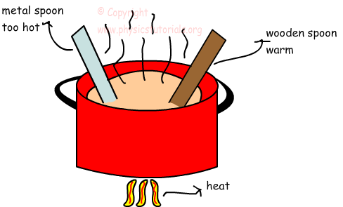
Good conductors allow thermal energy to move easily. Good insulators prevent the movement of thermal energy. Good insulation prevents the movement of thermal energy by preventing conduction, preventing convection, and preventing radiation.
CURRICULAR COMPETENCIES
Questioning and predicting—can students generate their own questions?
Planning and conducting—can they design and plan an experiment?
Processing and analyzing data and information—can they record data and see patterns?
Evaluating—can they draw conclusions from their data?
Applying and innovating—can they improve their design?
Communicating—can they talk, write and draw about their learning?

WHY IS THERMAL ENERGY IMPORTANT?
- Sources of heat are very important in terms of habitable life range; in cooking; in keeping food warm or cool.
- Keeping body temperature stable in very hot or cold environments.
- Understanding how heat travels has a wide range of applications in nature, the home, architecture, mechanics.
KEY VOCABULARY
Heat: energy associated with the movement of atoms and molecules in any material
Thermal energy: the energy that is generated and measured by heat
Particles: is a very small portion of matter (we can also use atom or molecule)
Motion: movement or vibration
Conduction: the transfer of heat energy from one atom to another in an object due to direct contact.
Convection: the transfer of heat energy that can only happen in liquids and gases, because it involves those liquids or gases physically moving; heated particles are further apart, less dense so they rise.
Radiation: the transfer of heat energy in waves, which does not require any particles (for example, the sun’s heat comes to us through space, where there are no particles).
Insulator: a material that reduces the flow of heat energy.
Conductor: a material that easily allows the flow of heat energy.

SOME INQUIRY QUESTIONS
- What’s the best spoon to stir a pot of soup?
- Why are toilet seats cold even if the air in the bathroom isn't?
- What’s the best natural material to use as an insulator?
- How did Coast Salish First Nations insulate their living quarters before colonization?
- What would be some advantages of using these natural insulators now?
- Why did Inuit traditionally build temporary winter shelters out of snow? Isn't snow cold?
- What has more thermal energy—a tea cup at 90 C or an ice berg?
SUGGESTED PROVOCATIONS/ACTIVITIES/EXPERIMENTS
Why use a thermometer?
Fill a cup with very warm water (but not burning the skin) from the tap, and a cup with ice water. Label them HOT and COLD. Fill a third cup with room temperature water, label with a question mark. Have a student place a finger in the HOT cup, and another place a finger in the COLD cup. After 15-20 sec, have them move their fingers to the same ? cup. Ask them if it is warm or cool.

Heat vs. Temperature
Teach students to use a thermometer. Have them measure the temperature of a large container of hot water vs. a small container of hot water. Repeat the measurement each minute for 10 minutes. Why does the small container cool down more quickly? Use this to discuss HEAT versus TEMPERATURE.

Sources of Heat
Do a carousel with a candle, a lamp, a hand-warmer, a mitten, a hand-warmer (resusable or non-reusable), a hair dryer, sandpaper and wood (instruct to sand) and other items. Have students say whether these things make heat. If so, what is the SOURCE of the heat?

Friction heat
Students can investigate friction using a thermometer and their hands—taking the temperature before and after rubbing their hands. Or, fill a coffee cup with sand, tape the lid on, cover the hold with your finger and shake. Measure the temperature after different speeds of shaking.

Hand Warmers
Investigate the handwarmers—how do they work? How long do they last? You can also use these to measure the insulating effects of different types of cups. https://www.wired.com/2014/12/whats-inside-hot-hands/

Radiation
A radiometer helps measure heat energy. If you have a south facing window, you can also do a tracing of the sun. Compare melting rates on a black plate vs. a white plate (or use different colours of plastic container lids).

Conduction
Use these plates to compare the difference between conductive materials and insulating materials. Have students do a “Predict, Observe, Explain” before placing the ice-cubes on them. These are available in the Thermal Energy Kit from the DLRC. https://www.teachersource.com/product/amazing-ice-melting-blocks/energy
Stir a hot cup with spoons of plastic, metal and wood. Which spoon conducts? How do you know? What are the properties of this cup?

Convection
Two ideas to engage in convection. First, fill clear cups/beakers/glasses with hot, warm and cold water. Then have students put a drop of food colouring in each. Observe after 30 sec and 1 minute and 5 minutes. Secondly, use a convection ring (available in the Thermal Energy Kit from the DLRC) to demonstrate. It is also possible to make an entire fish tank into a convection cycle: https://www.youtube.com/watch?v=B8H06ZA2xmo

Insulation
Test various materials using either warm water or ice water to see how temperature changes when insulated. Design and investigate the insulating properties of some natural materials used by insulation for our First Nations people: wood chips, wool and cat-tail fluff. (Information and materials in the kit from the DLRC).

CROSS-CURRICULAR CONNECTIONS
A Camping Spree with Mr. Magee by Chris Van Dusen—a good book to SET YOUR PURPOSE—why do we need to worry about heat? How can you camp comfortably? (Eventually, this book will be in the Thermal Energy Kit)
On a Beam of Light by Jennifer Berne is the perfect anchor book for questioning and considering curiosity…. a necessary trait for scientists.
INDIGENOUS PERSPECTIVES
Stories about the Sun

Bentwood Box cooking: https://www.youtube.com/watch?time_continue=5&v=6d9P-ODggaM

Coast Salish people use racks for drying (heat from sun) and cooking fish; salmon smokehouse for drying and storing http://firstpeoplesofcanada.com/fp_groups/fp_nwc3.html

Coast Salish Insulation—using bull rushes (also known as cat-tail fluff), both the leaves for weaving mats and the fluff for insulation, wool traded from Sto:Lo as a warm clothing insulation.

Currently, many First Nations are exploring Solar Energy (this video is for teacher info): http://aptnnews.ca/2017/05/18/solar-panels-on-small-b-c-first-nation-make-big-impact/ )
RESOURCES
Bill Nye the Science Guy on Heat (2:05) https://www.youtube.com/watch?v=f1eAOygDP5s

Heat is the thermal energy that exists in matter: http://studyjams.scholastic.com/studyjams/jams/science/energy-light-sound/heat.htm

This is a great, old series of simple cartoons that explains all the concepts in this unit (each video is under 5 minutes): https://www.youtube.com/playlist?list=PL07249EFA9038FDC1 Episodes 20, 21, 24, 27, 28, 29 are relevant to this unit.

Find a list of conductors/insulators here: https://physics.info/conduction/

References:
The Physics Hypertextbook: https://physics.info
SD71 Science Info (this is a great source of info for all science areas and includes FRENCH resources): https://portal.sd71.bc.ca/group/wyhzgr4/physics/grade3/Pages/Gr3physicsteacher.aspx
HOT
COLD
?

