GRADE 7 EVOLUTION SUMMARY DRAFT
Grade 7 Learning Standards (From BCEd Curriculum)
- organisms have evolved over time
- change in traits of populations over time
- survival needs
- all organisms need space, food, water, and access to resources in order to survive
- natural selection
- the natural process by which certain traits that have a greater fitness for their environment lead to a reproductive advantage; this process happens within a population over time because of genetic variation
WHAT DO Grade 7’s need to know about Evolution?
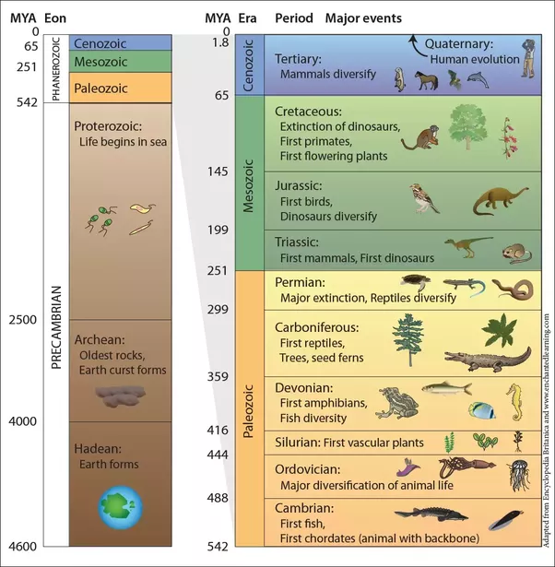
Evolution is the change in living things over time. In science, evolution is not controversial, as there is agreement on the fact of evolution because there is strong evidence that there have been forms of organisms that existed in the past that no longer exist (from the fossil record), and there has been observation of the changes in living organisms through time.
Nothing in Biology makes sense except in light of understanding evolution.
This is the best place to explain to students how the scientific term THEORY is different than HYPOTHESIS. A theory is not a guess or conjecture, rather it is a BIG IDEA that ties together numerous other ideas, that has a large number of pieces of supporting evidence, and THAT HAS NEVER BEEN CONTRADICTED BY EVIDENCE. The theory of evolution by natural selection is a unifying and foundational idea in biology, not controversial in any way among biologists.
Grade 7 students need to understand the immensity and length of geological time. When we talk about evolutionary change, it does NOT happen in an organism’s lifetime, but takes hundreds of generations to occur. That is why we can observe evolution taking place in bacteria, which have a generation time of 24-48 hours, but it is much harder to see in longer-lived organisms. Natural evolutionary change by natural selection takes a long time—artificial selection such as that used by farmers and breeders can be quite short.
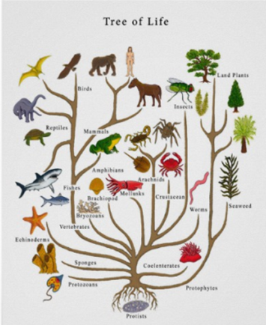
Teach Grade 7 students about the geological time scale, and how LONG it actually is! Features of the GTS they should know: the true lengths of time (and how tiny our current era (Cenozoic) and Period (Quaternary) are—just a blink of an eye. Students should also be aware of the major mass extinctions between the periods and the hypotheses about what caused them.
The next thing for Grade 7’s to learn is the evidence that has helped develop the geological time scale and helped to support evolution. First, the fossil record. Students should understand how fossils are made, how unlikely it is that living things will be fossilized intact, and how fossils can be dated by relative position in the layers, or by the more precise radiometric dating. Fossils show us organisms that existed in the past but no longer exist, and also how organisms have changed over time. The distribution of fossils over the planet also shows us how the earth has changed geologically.
Homologous features of living things also provide evidence for evolution. We can compare the forelimbs of different animals, for example, to see that the basic design of these structures is similar, even though they have evolved and adapted for different purposes. So we can see the same structure in a whale flipper, a bat wing, a chicken wing, a cat’s leg and a human arm.
DNA similarities provide evidence of evolution. We can trace some of our key DNA sequences (for proteins important to cells, for example) back along the tree of life to single celled protists. As we move along the family tree, our DNA becomes more and more similar to our closer ancestors—we share about 97% of the same functional DNA with orangutans, but about 99% similarity with Bonobos and Chimps! We share 80% of a cow’s DNA, 75% of a mouse’s, but only about 60% of a fly. This makes sense if you look at our relationships on the tree, and gives further evidence for evolution.
Artificial selection—breeding for traits by farmers—is an example of evolution in action, greatly speeded up. The development of anti-biotic resistance in bacteria is also evidence of evolution.

After understanding the time scale and evidence, Grade 7’s should get a firm grasp of what evolution IS and IS NOT. Evolution happens to populations of organisms over long geological time. It does not happen to individuals in their lifetimes. It IS a shift in the genetic make up of a population based on the environment acting on visible features of the organism.
In response to environmental change, migration, or competition from other species, organisms have pressure put on them to survive. Here is a summary of how natural selection happens with visuals:

A Summary of Evolution by Natural Selection
Evolution is the change in populations of organisms over time--not change in the individual organisms, but change in the population of organisms. It has happened and is happening all the time. Organisms that once roamed the earth are now extinct (for example, dinosaurs). New species are evolving. The theory of evolution by natural selection has the following six main points:
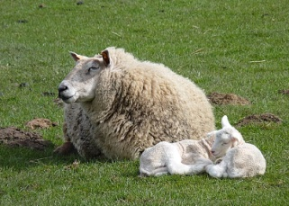 | 1. All life forms (species) have developed from previously living species.  Sheep give birth to baby lambs.
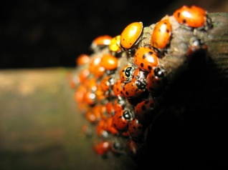 | 2. All living things (unless they are clones) are genetically different from each other. Much of this difference is inherited.  All ladybugs are different, even if we can’t see the differences.
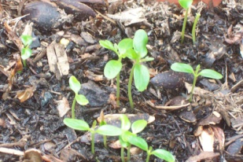 | 3. More organisms are born/germinated that can possibly live to adulthood.  Only a few of these Australian red cedar seedlings can grow into trees.
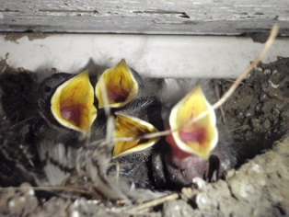 | 4. Organisms must compete with each other and the environment in order to survive.  These baby barn swallows compete for food.
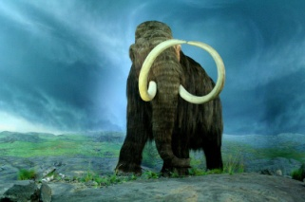 | 5. The process by which one species evolves into another involves random heritable genetic mutations (changes) and genetic mixing due to sexual reproduction. Mutations and combinations that result in a survival advantage for organisms are more likely to spread and persist than mutations that do not result in a survival advantage and/or that result in a survival disadvantage.  Wooly mammoths are now extinct.
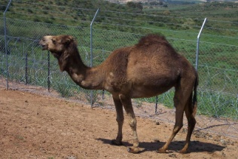 | 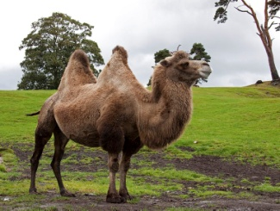  6. Over time, these changes or adaptations create new species from old ones.  Dromedaries (one hump camels) and Bactrian (2-humped) camels became distinct species about 8 million years ago.  (Text adapted from Biology by Miller-Levine, teacher's edition)

CURRICULAR COMPETENCIES
Questioning and predicting—can students generate their own questions?
Planning and conducting—can they design and plan an experiment?
Processing and analyzing data and information—can they record data and see patterns?
Evaluating—can they draw conclusions from their data?
Applying and innovating—can they improve their design?
Communicating—can they talk, write and draw about their learning?

WHY IS IT IMPORTANT?
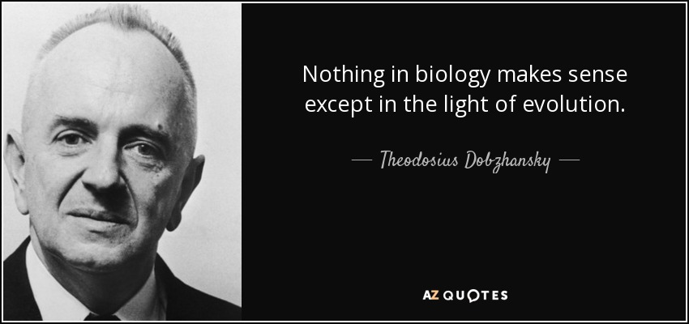
KEY VOCABULARY (include definitions)—coming soon
SOME INQUIRY QUESTIONS
- How have humans evolved?
- What is the evidence for evolution
- What was Darwin’s major contribution?
- Are there any examples of evolution in action?
- Are we entering a new era—the Anthropocene?
- Will dinosaurs evolve again, now that the climate is warming?

SUGGESTED PROVOCATIONS/ACTIVITIES/EXPERIMENTS
Simulate making some fossils. Ideas here: https://craftsbyamanda.com/coffee-ground-fossils/
Learn about relative dating from rock layers…for example, this Barbellus activity: http://faculty.montvilleschools.org/bhayes/biology/handouts/evolution_of_barbellus.pdf
Explore the geological time scale—make a poster to scale using adding machine tape http://www2.mbusd.org/staff/pware/pdf/GeologicalTimeline.pdf or make one along your school hallway file:///D:/SanDiskSecureAccess%20Vault/MathScience%20Consultant/Elementary%20Science/Inquiry%20Workshop%20Participants/activity_Time%20of%20Our%20Life.pdf
Teach the steps of natural selection and act it out using beans
https://manoa.hawaii.edu/exploringourfluidearth/biological/what-alive/evolution-natural-selection/activity-simulate-natural-selection
http://www.uvm.edu/~bio1and2/lab/Lab%20manuals%20Fall%202012/Natural%20Selection.pdf or observe another simulation like this peppered moth simulation: http://peppermoths.weebly.com/
CROSS-CURRICULAR CONNECTIONS
There are some marvelous movies and books that connect learning. More mature Gr 7 readers may enjoy Charles and Emma by Deborah Heiligman https://www.npr.org/templates/story/story.php?storyId=120618782
Art—drawing different plants and animals can help students observe their connections. Draw different brassicas and determine how they evolved from wild mustard https://www.businessinsider.com/broccoli-kale-brussels-sprouts-vegetables-all-the-same-plant-2015-11 draw the forelimbs of a variety of skeletons and see how their structure is homologous: https://www.quora.com/What-are-homologous-structures-What-are-their-functions
INDIGENOUS PERSPECTIVES (to be expanded)
Indigenous ecological perspectives are at their core more connected to evolutionary biology than many western traditions. For example, in Coast Salish culture, human clans are denoted by predators (bear, coyote, raven, eagle, killer whale), noting the evolutionary and ecological relationship of humans and these equal organisms.
The Indigenous world view that all things are connected and all things are related is actually the big idea behind evolutionary biology, which Western science came to relatively recently. More discussion of this can be found here: Indigenous Knowledge, Ecology, and Evolutionary Biology by R. Pierotti. Routledge, 2011.
RESOURCES
I recommend these 3 websites—they are filled with scientifically accurate information, many videos and on-line resources, and lesson ideas.
University of California Museum of Paleontology: https://evolution.berkeley.edu/evolibrary/teach/68lounge.php

PBS Evolution (this has a great section on religion if you or your students have some struggles):
http://www.pbs.org/wgbh/evolution/
HHMI site on evolution:
http://www.hhmi.org/biointeractive/evolution-collection

Great Videos
National Geographic’s The Story of Earth takes a deep look at the earth’s formation, and gives that sense of deep time necessary to understand evolution: https://www.youtube.com/watch?v=SYOarZKipnU
Before or after doing the natural selection bean experiment, consider the following video about the pocket mouse (there is a bit of technical genetic information that you can skip through):
https://www.youtube.com/watch?v=sjeSEngKGrg

