Black History Month STEM Edition February 2021
WEEK 1 & 2: Black Canadians in STEM
Mon 1 | Tues 2 | Weds 3 | Thurs 4 | Fri 5
Anderson Abbott  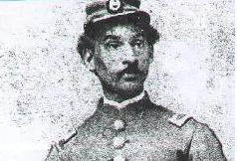  First Black Canadian medical doctor trained in Canada | Onye Nnorom  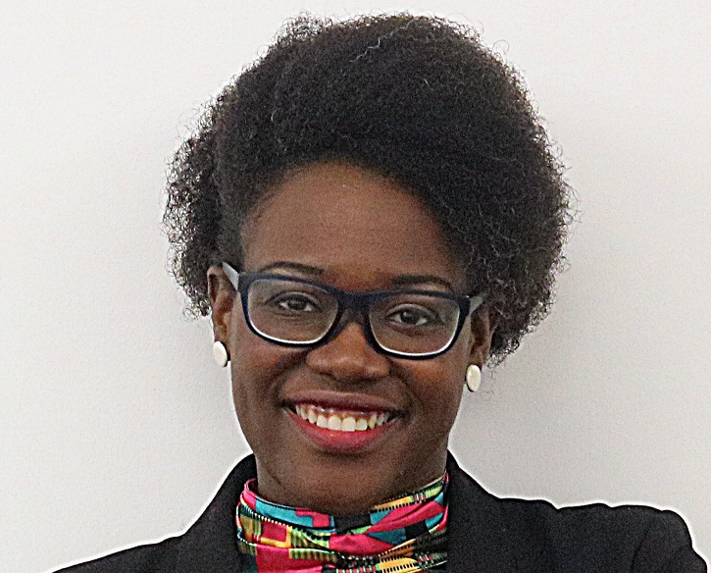  Physician and specialist in public health inequities. | Alfred Shadd 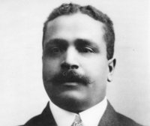  Educator, medical doctor, politician, human rights advocate. | June M. James  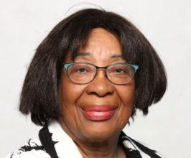  First woman of colour admitted to U of Manitoba Medical School. Expert in pediatric allergies | Elijah McCoy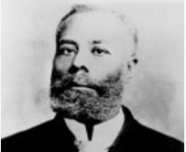  Engineer with over 60 patents, whose work greatly increased train efficiency.
Mon 8 | Tues 9 | Weds 10 | Thurs 11 | Fri 12
William “Painless” Jones  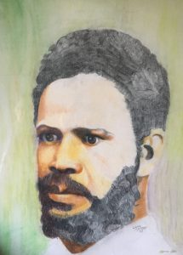  BC’s first licensed dentist, practicing in Barkerville, BC. | Clotilda Yakimchuk  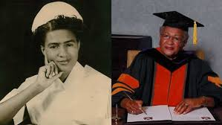  In 1954, she became the first Black graduate of the Nova Scotia Hospital School | Michael Lee Chin  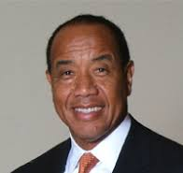  Engineer and entrepreneur, runs AIG, one of Canada’s most successful investment companies. | Melissa Hafting  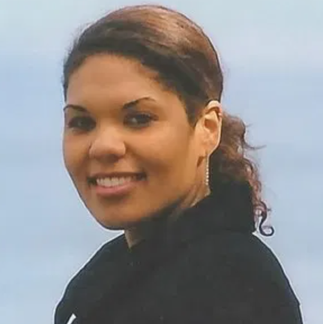  Conservation biologist and prominent birder, running the BC Young Birders program. | Jamal Deen  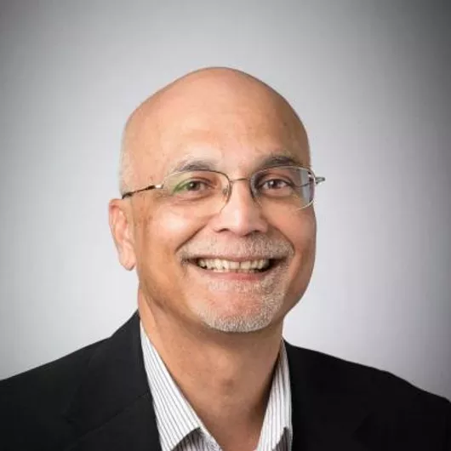  Order of Canada holding Senior Canada Research Chair in Information Technology at McMaster University
Great resources:
Periodic Table of Canadian Black History: https://cbhtable.com/table
BC Black History: https://bcblackhistory.ca/black-history-month/
Canadian Black Scientists Network: https://www.blackscientists.ca/

