
“Empower Educators, Inspire Learners”

How to Access and Read Lightbox™ and AV2 World Language Interactive eBooks
1. Go to Go to: www.destinydiscover.com (any browser should be fine but many people report the best experience using Chrome)
2. Location box – leave it as Any Location
3. In the School Box type in:
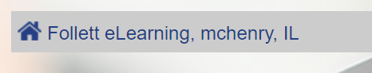
4. Click “Log In” in the top right-hand corner
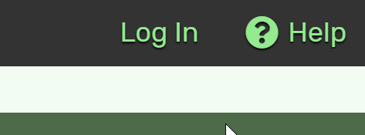
Username: guest
Password: follett
Searching for and Accessing Titles:
There are several ways you can search on the site:

1) Typing in a keyword in the Search (results for both AV2 World Language and Lightbox titles)
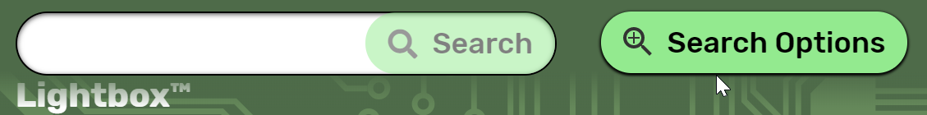

2) Go into Search Option and then filter by Interest level or Reading Level (results for both AV2 World Language and Lightbox titles)
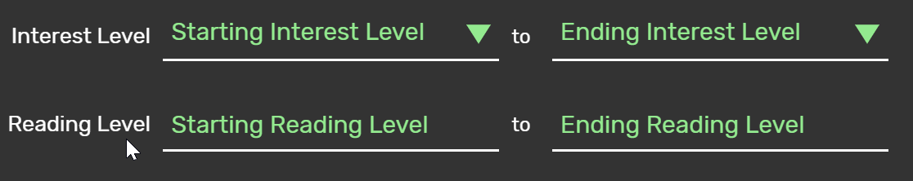
3) Go to Lightbox and click See All and pick a title you like (Lightbox titles only)
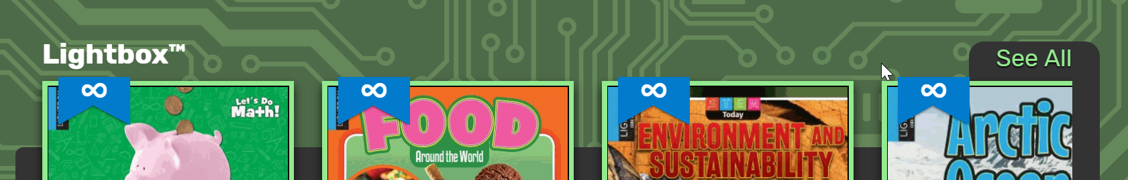
4) Scroll down to Learning links and click AV2 (AV2 World Language titles only)
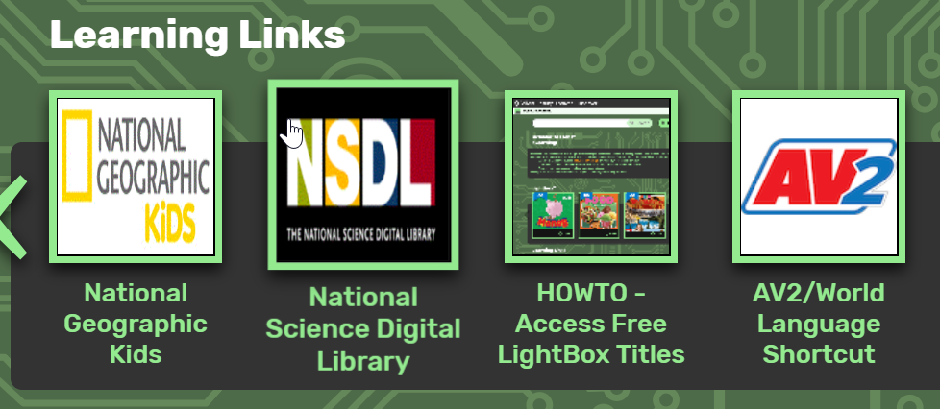

Lightbox Titles
Click Open and a new tab on your browser will open with the title. If you are prompted for a username and password it is the same as the Log In (username: guest; password: follett).
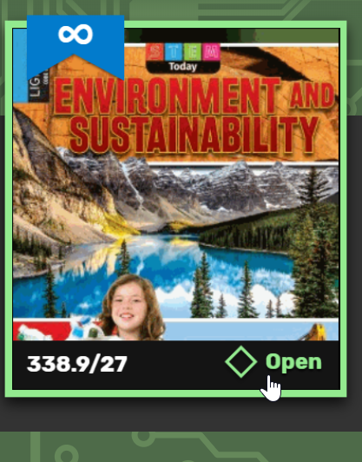
Click the red Open Lightbox
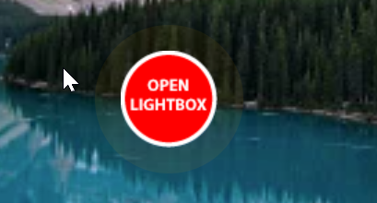
The home page explains what all the symbols on each page mean at the bottom.
To move through the pages click the arrow on the right hand side:
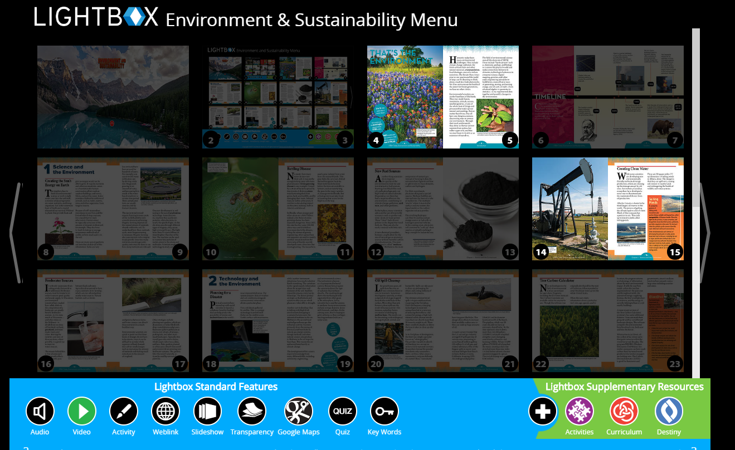
This page has a video on it that you can watch and if there is a word in bold – click on it, and the definition comes up etc.
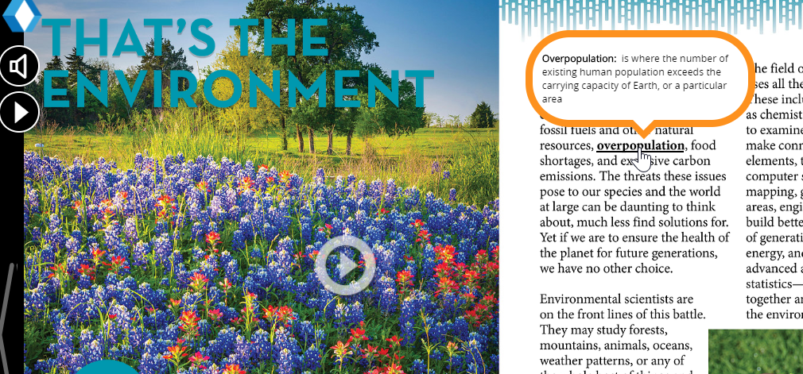
The available features on each page, including text-to-speech, can be found on the left hand side.
There are additional activities at the bottom right of the first page:
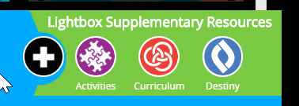
For example this book has 7 pages of activities
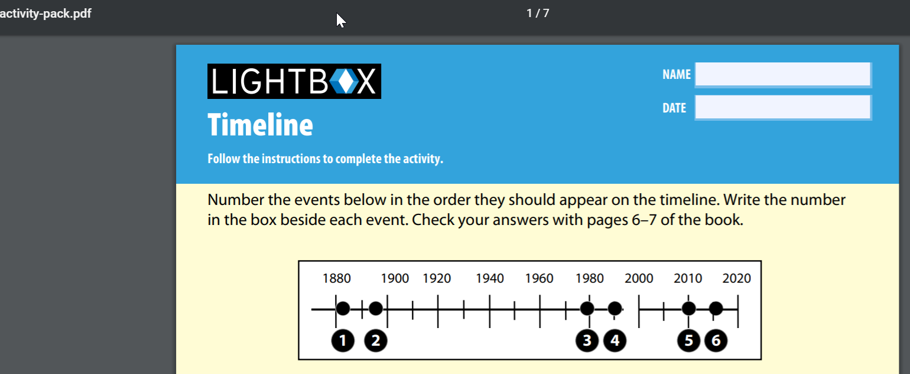
To close the book simply close the browser tab
AV2 World Language
Click Open and a new tab on your browser will open with the title. If you are prompted for a username and password it is the same as the Log In (username: guest; password: follett).
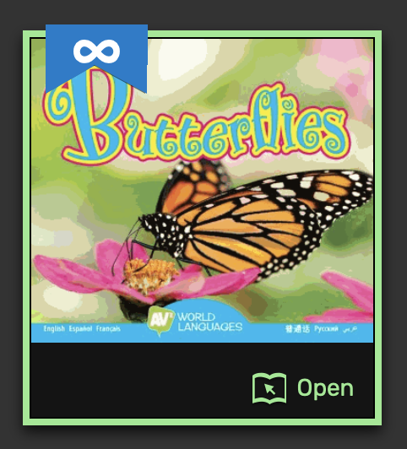
At the bottom right you will see the ten languages in which you can read the book
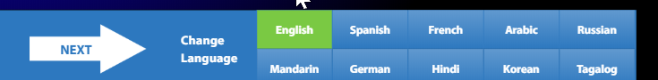
Select the language you are interested in and click the button
To have the text-to-audio activated, click on the “Read” button at the bottom of the page (this will appear as “Read” regardless of the language you have selected).
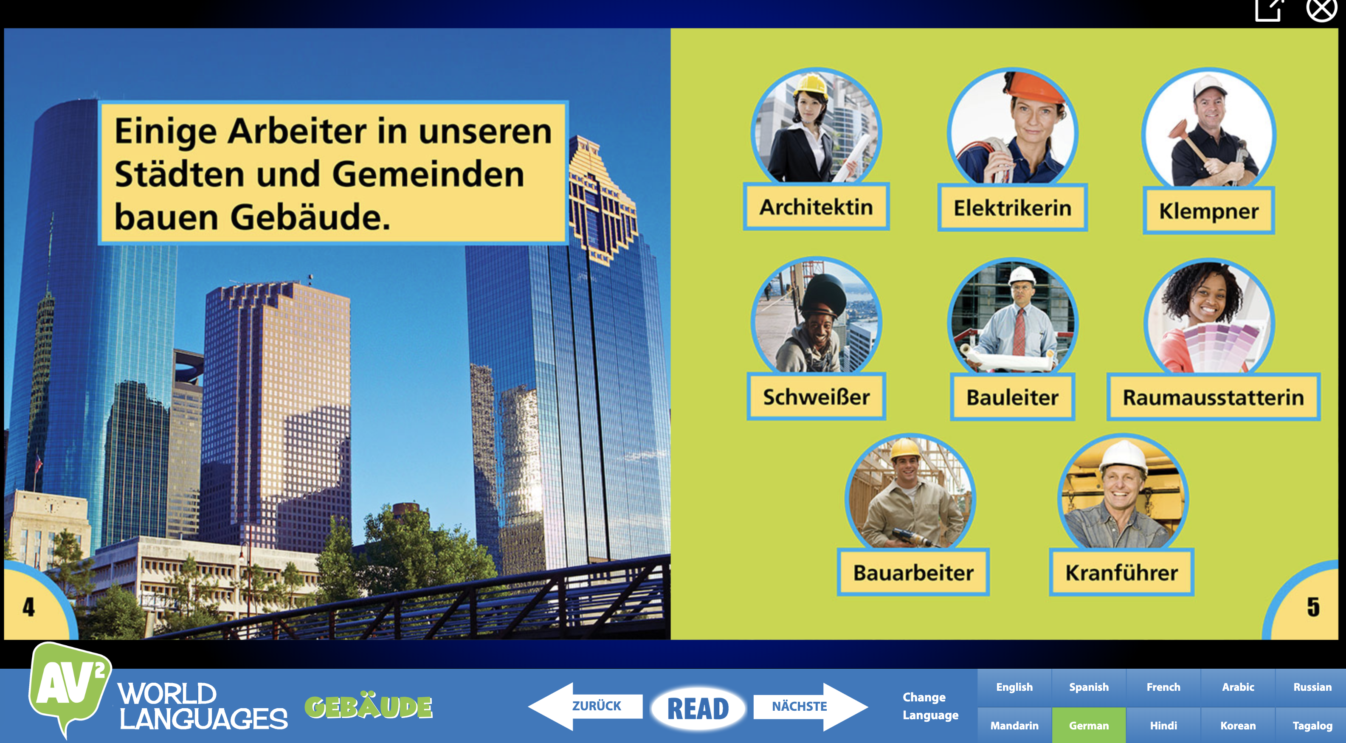
To close the book, simply close the browser tab.

